Margherita Pizza
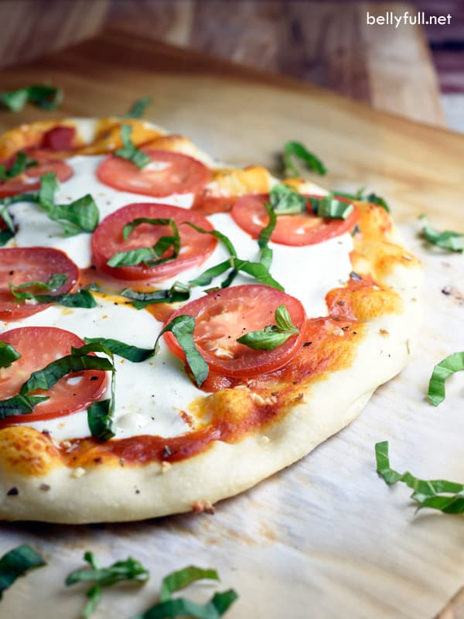
8 Servings
Ingredients
1 can (13.8 oz) Pillsbury™ refrigerated thin pizza crust
1 tsp extra-virgin olive oil
1 garlic clove, halved
5 plum tomatoes, thinly sliced
1 cup (4oz) shredded fresh mozzarella cheese
1 tsp balsamic vinegar glaze
½ cup thinly sliced fresh basil
1/8 teaspoon salt
1/8 teaspoon pepper
Directions
- Heat oven to 400 degrees for dark or nonstick pan (425degrees for all other pans). Spray 15x10x1-inch pan with cooking spray.
- Unroll dough in pan; starting at center, press dough into 15x10-inch rectangle. Bake 3 minutes.
- Remove crust from oven and brush with olive oil. Rub crust with cut sides of garlic.
- Arrange tomato slices on crust, leaving a 1/2-inch border; sprinkle evenly with cheese.
- Rotate the pan 180 degrees and bake an additional 5 minutes.
- Sprinkle pizza evenly with sliced basil, salt, and pepper. Drizzle the balsamic vinegar glaze evenly over the pizza. Cut pizza into 6 rows by 3 rows.

